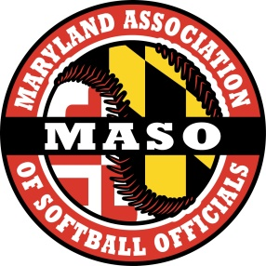
www.masosoftball.org

For information of becoming a high school softball umpire in Baltimore City, Baltimore County, IAAM (private schools) and Carroll County, please email dvpabst@comcast.net, MASO (Maryland Association of Softball Officials) Instructor.

For information of becoming a high school official in other sports and counties, please follow this link www.mpssaa.org. Maryland Public Secondary Schools Athletic Association will have all the information you need to get started.

